Final Report

**1. Introduction**

In this report I seek to understand the correlation between Death Valley attendance and smoke estimates/AQI in Pahrump, NV. For this project we were encouraged to “help inform the city council, city manager/mayor, and city residents about the potential future impacts of smoke on their community” (SOURCE) through the lens of a human centered data science question. I chose to examine Death Valley attendance due to the impact tourism likely has on the economic viability of Pahrump.

From Pahrump’s Wikipedia page, it would appear that the town’s economic activity centers on two wineries and two legal brothels (*Pahrump, Nevada*). While it may have been possible to infer potential impacts on Pahrump’s industries from data linking smoke and winery production generally, I wanted to study economic activity more directly. A search for Pahrump on TripAdvisor revealed multiple tours to nearby Death Valley National Park (The 15 best things to do in Pahrump - 2023 (with photos)). In addition, when one plots a course from Las Vegas to Death Valley on Google Maps, one of the two primary routes goes directly through town. From this data I conclude that tourists originating in Las Vegas likely drive through town, filling up their cars, buying snacks, and gathering provisions for the park. Each of these actions provides direct economic benefit to the town. This hypothesis is bolstered by the approximately 20% of adults in Pahrump who work in “Accommodation and Food Services”, or “Arts, Entertainment, and Recreation Industries”, well above the total national average of 9%. It is distinctly possible that the proximity of Death Valley drives additional employment in these sectors (Economy in Pahrump, NV). Beyond tourism, Pahrump locals may also be employed to work in the National Park or to maintain outside infrastructure (e.g., road crews, firefighters).

Identifying a correlation between smoke estimates/AQI and Death Valley attendance would allow citizens of Pahrump to diversity their industries or challenge their government to do more about fire prevention in the event that smoke/poor air quality should increase.

**2. Background/Related Work**

Some research has already been conducted on the impact of wildfire smoke on National Part attendance. Clark et. al found in modeling black carbon (an element of wildfire smoke) and recreational visitation to 32 US National Parks that “The results of these models are mixed, but overall show little to no effect of ambient smoke on visitation to the 32 parks tested, even when allowing for critical thresholds at the extreme upper ranges of smoke exposure. This indicates that wildfire smoke does not greatly alter park attendance” (Clark et al., 2023). Gellman et al. executed a similar analysis of wildfire smoke and federal campgrounds in the US between 2008 and 2017 and found “[…] fire and smoke affect 400,000 and 1 million visitor-days per year, respectively […but] the magnitude of the smoke effect is small […] suggesting that smoke fails to deter most visitors to public lands” (Gellman et al., 2022).

These findings run contrary to expectations, though it is important to remember that correlation does not imply causation. While wildfire smoke may be burdensome to National Park visitors, it is possible that significant investments of time and money could make them reluctant to change or cancel plans.

For my analysis I will examine the correlation between Death Valley attendance and smoke estimates/AQI estimates in Pahrump, NV. Despite earlier research, I would hypothesize a negative correlation between smoke estimates/AQI and park attendance. Given many park visitors likely originate in the Las Vegas area, they could easily avoid the hassle of driving to the park and have many alternate entertainment options available. The impact of smoke on local visitors (e.g., those who live in and around the park) is less clear and will be addressed in the “Limitations” section of this paper.

There has also been significant prior work to quantify smoke from wildland fires which I use in my smoke estimate calculations. My estimates leverage the USGS Wildland Fire Data (Welty and Jeffries, 2021), which includes fields such as type of fire, acres burned, distance to town, recency of other fires in the same area, and year of fire recording.

A basic smoke estimate includes the acres burned multiplied by . I assume that the acreage burned is proportion to the amount of smoke, and that smoke diffuses in air with an inverse-squared relationship similar to light. However, I also believe other factors such as type of burn, recency of burn, and data accuracy impact how much smoke is created.

Per David Frisbey's 2008 thesis "A comparison of smoke emissions from prescribed burns and wildfires", "The results suggest that the smoke impacts of a wildfire may not be any greater than a prescribed burn when compared using the methodology. This research demonstrates how a combination of the fuel load and the size of the burn may be more significant in controlling downwind concentration of PM10 than the atmospheric conditions. Even when there is a planned burn under prescribed meteorological conditions there can be significant impacts if the size of the burn and fuel loading are not also considered" (Frisbey, David, 2008). Examining “Forest Service Professionals Prepare for a Prescribed Burn” (Avitt, 2023), we can see that forestry services do take fuel moisture, forest stand characteristics, historical data, terrain, and elevation into account when creating a prescribed burn. Given David's findings, and assuming the Forest Service correctly accounts for the fuel variables to create less intense blazes, I multiply my basic smoke estimate for prescribed burns by 0.50.

I also assume that fires in areas burnt within the last 2 years should produce much less smoke than otherwise calculated. The idea of a differential burn is supported by “Burn out: Frequent fires are changing Western landscapes” (Pontecorvo, 2020). For the areas of a fire burned within the past 2 years, I multiply the basic smoke estimate by 0.20.

Finally, the USGS wildland fire metadata note that "Areas burned prior to 1984 in this dataset represent only a fraction of what actually burned. While areas burned on or after 1984 are much more accurate and complete, errors still can and do occur." Given the underestimation of acres burned, I multiply the smoke estimates for fires prior to 1984 by 1.5.

There are limitations with this smoke estimate, including no variable for fuel composition, weather, terrain, etc. which will be discussed in more detail in the “Limitations” section of this report.

AQI data is sourced directly from the EPA’s API, the code for which can be found in my “epa_comparison” script (Ekrolen).

Death Valley attendance data is sourced from National Park annual attendance records. While the land was officially declared a National Park October 31st, 1994, the National Parks Service has kept attendance records for the site since 1933. The data consists of year of park visitation and annual total number of recreation visits. Per the National Park Service’s Visitor Use Statistics Page, a “Recreation Visit” is “The entry of a person onto lands or waters administered by the NPS except as defined above for non-reportable and non-recreation visits [e.g., entry into the park by NPS employees or contractors, commuter or through traffic, guides, government personnel with business in the park]. Funeral parties at National Cemeteries, school groups, etc. are reportable as ‘recreation’ use since their use is for the purpose for which the park was established. Visits originating on surface vehicles (trains, boats, other) and aircraft may be counted if they stop and disembark passengers on NPS administrated territory. The applicable rule is that one entrance per individual per day is countable” (U.S. Department of the Interior, 2023). Per the National Parks Service Disclaimer page, “Copyright law does not protect “any work of the U.S. Government” where “a work prepared by an officer or employee of the U.S. Government as part of that person's official duties” (See, 17 U.S.C. §§ 101, 105). Thus, material created by the NPS and presented on this website, unless otherwise indicated, is generally considered in the public domain. It may be distributed or copied as permitted by applicable law” (U.S. Department of the Interior, 2020).

**3. Methodology**

My process generally consisted of defining and calculating the smoke estimate, calculating the AQI, comparing the two, and testing correlation with Death Valley attendance. I will walk through each step in the following paragraphs. Detailed technical information can be found in my repo’s README and scr/ code files (Ekrolen).

**3.1 Smoke Estimate**

I began by downloading and unzipping the GeoJSON Files.zip “Wildland Fire Polygons Fire Feature Data Open Source GeoJSON Files” from USGS (Welty and Jeffries, 2021). Of the GeoJSON exports I used the “combined” dataset to avoid duplicated fires from data merges. Due to GitHub file size restraints, I saved the "USGS_Wildland_Fire_Combined_Dataset.json" file to the directory above my project’s parent directory with the intent of reducing the data then saving it to the intermediate_data folder.

For my analysis I limited fires to those occurring after 1963 and within 1250 miles of Pahrump, NV. The first script, data_acquisition, reads in the fire GeoJSON information and finds the distance between the closest edge of each fire and the center of Pahrump. I chose to use the edge of the fire rather than the center because it may be closer to town resulting in more smoke. However, I did choose to center the Pahrump town coordinates to avoid biasing smoke measurements to one side of the city. The fires which lie within 1250 miles of Pahrump are kept.

Next, I extracted a list of fires which occurred after 1963. This list was inner joined with the set of fires which occurred within 1250 miles of Pahrump to create our fire sample set.

Then I created the annual smoke estimate. The research behind the estimate calculation is detailed in the “Background/Related Work” section above, however I will post the final smoke estimate formula below. This estimate was created for each fire occurring after 1963 within 1250 miles of Pahrump.

To create an annual smokiness estimate I averaged the Final Smoke Estimate across all fires per year. This method was chosen initially because it would be compared to AQI measurements over the same season, thus no amortization was necessary to “extend” the smokiness to the rest of the year. However, it is worth noting that our Death Valley attendance numbers are given annually, thus a kind of “amortization” to estimate the annual smokiness may have been more appropriate. It's also worth noting that initial results contained a summed annual smokiness estimate rather than an averaged value due to an accidental code change. While updates to reflect the average annual smoke estimate have been propagated through all code, changes were not made to project documentation submitted prior to 12/11/23. Additionally, we continue to use the linear smoke prediction model and code as was written for the summed annual smokiness estimate, though it no longer appears to be a good fit for our data.

**3.2 AQI Estimate**

AQI data is pulled from the EPA AQS API. I began by pulling information about different air quality measures to identify the 5-digit code corresponding to AQI. I then retrieved the 5-digit codes which represented individual AQI elements (e.g., 42101 represents carbon monoxide). These 5 digits codes were combined into gaseous and particulates lists for later querying. Then I created a dictionary with information on Pahrump, including the center of town’s latitude/longitude coordinates from the smoke estimate. A call to the list request function returned all sensors within Nye County around Pahrump.

The crux of data acquisition lay in repeated API calls to the EPA AQS API requesting the daily summary of AQI information (gaseous or particulate) from the sensors in Nye County. While some stations produced more granular AQI information the EPA indicated “The Air Quality Index is based on daily air quality summaries, specifically daily maximums or daily averages. It is not valid to use shorter-term (e.g. hourly) data to calculate an AQI value.” (AirNow.gov, 2018). Thus only 24-HR BLK AVG AQI measurements were collected for each gas/particulate where available. Data was collected over fire season (May 1st - Oct 31st) for consistency of comparison with the annual final smoke estimate.

Typically, AQI would be calculated using the max particulate value, however our sensors only measured a single particulate, PM10. The daily per sensor values for PM10 were averaged to create a single AQI estimate per year.

I was interested in how closely my final smoke estimate mirrored the AQI and would have expected a strong positive correlation. However, in graphing the scaled smoke estimate against the scaled AQI the R2 value was 0.01 with a p-value of 0.78 - far above the threshold required for statistical significance. However, there were also limitations on my AQI calculation including location of sensors and limited data which will be discussed in my “Limitations” section. The residuals were not normally distributed in the relationship, which could result in inaccuracies in the p-value.

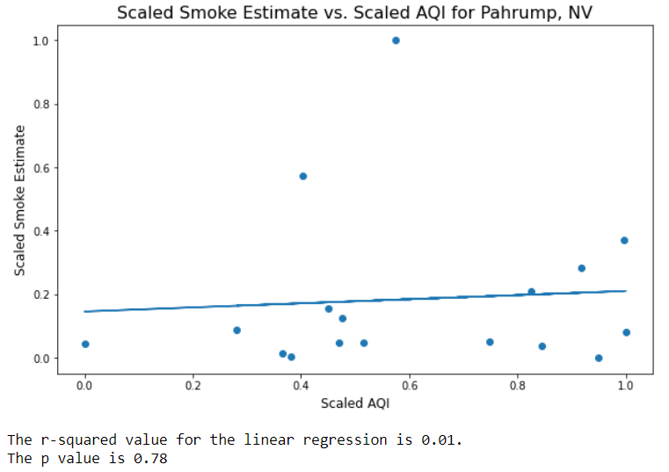

Figure 1. Scaled smoke estimates and AQI measurements do not appear to be correlated. Scaled smoke accounts for almost none of the variation in scaled AQI, and the p-value of the correlation coefficient indicates we fail to reject the null hypothesis (Beta = 0).

**3.3 Comparison with Death Valley Attendance**

Bringing in Death Valley data was fairly straightforward as it contained only the collection year and annual attendance. Some cleaning was required to remove the first 3 human-readable title rows so Pandas could process it correctly. Once stored in Pandas, the attendance data was merged into a larger table containing AQI and final smoke estimates to allow for easier graphing.

To map the correlations between smoke, AQI, and Death Valley attendance I used a linear regression model with both the independent variable (smoke or AQI estimate) and dependent variable (Death Valley attendance) normalized. I normalized both measurements to ensure they were on the same scale for visual analysis. I chose linear regression not only for its simplicity, but also for its Pearsons correlation coefficient which describes how much variability in the dependent variable is attributable to the independent variable. Additionally, I calculated a p-value for the coefficient which indicates its statistical significance.

**3.4 Ethical Implications**

I believe there are limited ethical concerns in using this data and modeling it in the above manner. It is possible that park attendance estimates do not accurately reflect all visitors and may leave out portions of the population (e.g., those who carpool may be more challenging to count) and fire data may be more accurate for areas with more resources (e.g., areas who could afford to send fire scouts, areas near fires, or areas with land/resources/items “worth monitoring”).

There are certainly ethical implications in how conclusions are interpreted. First, linear regression assumes 5 conditions (linearity, homoscedastic, normal distribution of errors, no/limited covariates, and no autocorrelation) to be a valid modeling technique. If these conditions are not met, I cannot assume the conclusions of correlation are valid. Additionally, it would be wrong to conflate correlation with causation. Even if I should find a strong correlation between smoke and park attendance, I could not say conclusively that smoke is what deterred visitors. Finally, I cannot state in totality how much of Pahrump’s economy would be harmed by smoke because of the correlation issue described above and because Death Valley-related business is likely only a fraction of total town income.

**4. Findings**

Visually it appeared that there was little if any correlation between the smoke estimate and Death Valley attendance. This was confirmed with an R2 of 0.0, and the coefficient was not statistically significant (0.63>>0.05). Examining the residuals vs. fitted values it would appear that residuals may be homoscedastic, and the Q-Q plot largely adheres to the guideline. Despite our belief that smoke would impact attendance, that doesn’t appear to be the case, and our results align with that of previous research.

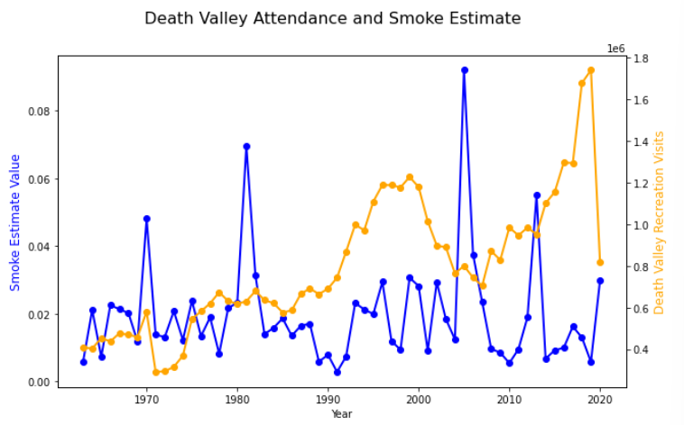

Figure 2. Annual smoke estimates and Death Valley attendance don’t appear to be visually correlated.

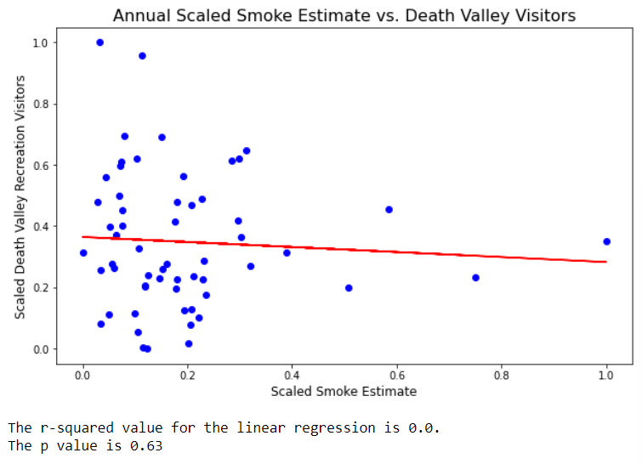

Figure 3. Lack of correlation appears to be confirmed by the linear regression model and p-value.

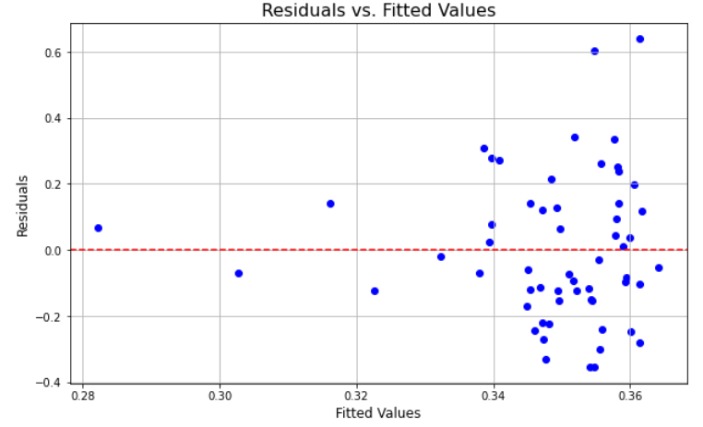 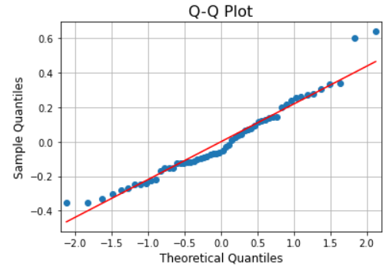

Figure 4. Resisudals are largely randomly distributed around 0.0, and conform to the guidline in the Q-Q plot.

Examining AQI and attendance it would appear that there is a stronger correlation. This is confirmed with an R2 of 0.33 and a p-value of 0.02. We also see that most assumptions for linear regression are met, adding confidence to the accuracy of the p-value. As with earlier research we cannot confuse correlation for causation. We cannot say conclusively that poor annual air quality leads to fewer park visitors, but it does seem to be a factor in the variation.

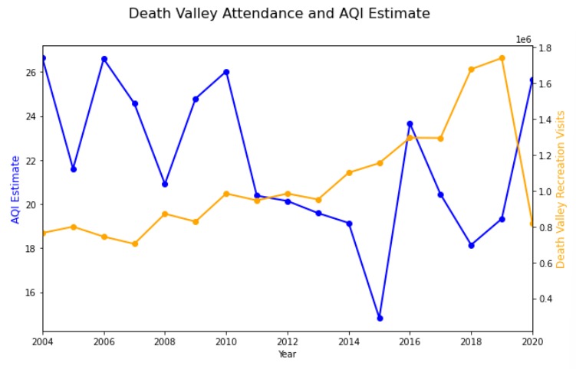

Figure 5. There may exist a negative correlation between annual AQI estimates and Death Valley attendance.

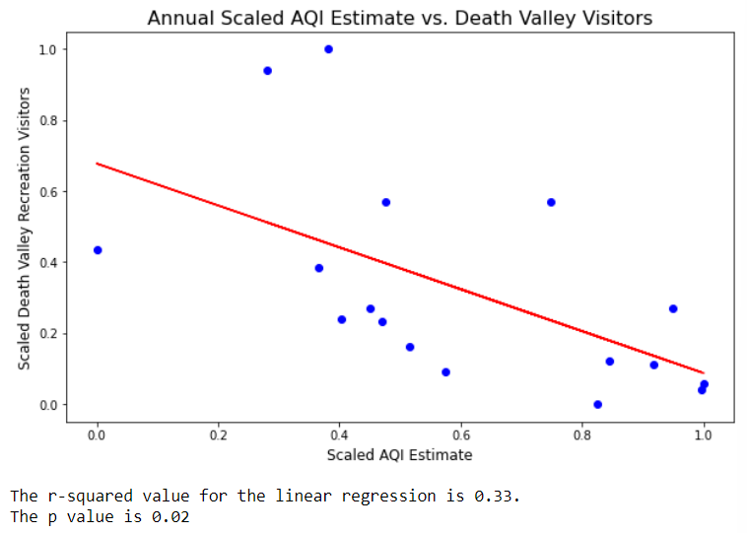

Figure 6. This apparent correlation is confirmed with a statistically significant correlation coefficient and an R2 of 0.33.

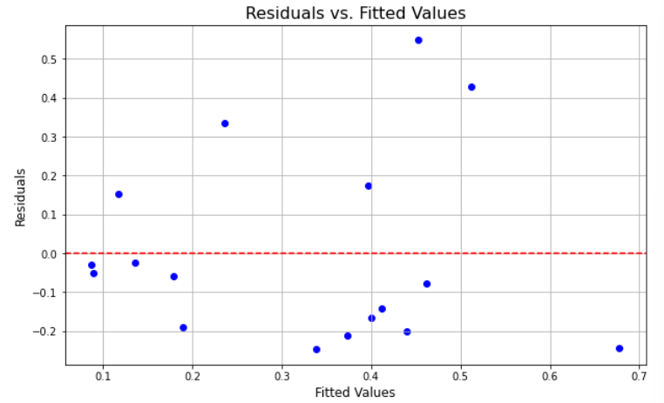 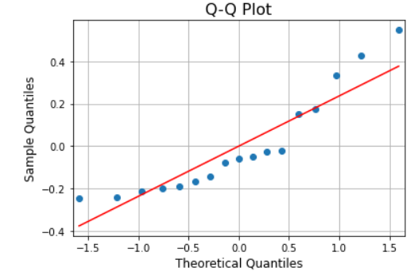

Figure 7. The residuals are fairly randomly distributed and largely conform with the guideline on the Normal Q-Q plot.

**5. Discussion/Implications**

1. Discussion/Implications

Why are your findings important or interesting; What should the city council, city manager/mayor, and city residents do to address your findings? How long do they have to make a concrete plan?

This section should include a thoughtful reflection that describes the specific ways that human centered data science principles informed your decision-making in this project.

1. Limitations

This is a required section for your report. There are often many, many limitations for any study. If you honestly tried to list them all, this might end up being the longest section. You should prioritize and list the ones that are most likely to have a significant impact on your results. Specific license issues could be a limitation, depending on what data sources you used. Flaws in the data, data cleaning techniques, potential assumptions and/or how you handled missing values could be a limitation. Statistical techniques often have specific assumptions and preconditions; if you’re not certain all of the data meets those requirements - this is a good place to make that clear.

Should have just done attendance during fire season, but couldn’t split by month

To create an annual smokiness estimate I averaged the Final Smoke Estimate across all fires per year. This method was chosen initially because it would be compared to AQI measurements over the same season, thus no amortization was necessary to “extend” the smokiness to the rest of the year. However, it is worth noting that our Death Valley attendance numbers are given annually, thus a kind of “amortization” to estimate the annual smokiness may have been more appropriate. It's also worth noting that initial results contained a summed annual smokiness estimate rather than an averaged value due to a last minute code change.

Composition of fuel certainly impacts the amount of smoke generated per acre burned. Given we are not currently bringing in additional vegetation information, we will assume a linear relationship between acres burned and smoke produced.

Many factors impact smoke dispersion (direction of terrain, wind, other atmospheric conditions), but we will focus on distance to town as our primary variable. We will assume that smoke disperses like light (1/distance^2 relationship), see Nasa.gov for more details.

The impact of smoke on local visitors (e.g., those who live in and around the park) is less clear and will be addressed in the “Limitations” section of this paper.

However there were also limitations on my AQI calculation including location of sensors and limited data which will be discussed in my “Limitations” section.

1. Conclusion

Restate your research questions/hypotheses and summarize your findings. Explain to the reader how this study informs their understanding of human centered data science.

**References:**

AirNow.gov. (2018, September). Technical Assistance Document for the Reporting of Daily Air Quality – the Air Quality Index (AQI). https://www.airnow.gov/sites/default/files/2020-05/aqi-technical-assistance-document-sept2018.pdf

Avitt, A. (2023, April 4). *Forest Service Professionals prepare for a prescribed burn*. US Forest Service. https://www.fs.usda.gov/features/professionals-prepare-for-prescribed-burn.

Clark, M., Killion, A., Williamson, M. A., & Hillis, V. (2023, June 7). *Increasing wildfire smoke has limited impacts on national park visitation in the American West*. Ecological Society of America. https://esajournals.onlinelibrary.wiley.com/doi/10.1002/ecs2.4571.

*Economy in Pahrump, NV*. Pahrump, NV. (n.d.). https://www.bestplaces.net/economy/city/nevada/pahrump

Ekrolen. (n.d.). *Ekrolen/data-512-wildfire-project*. GitHub. https://github.com/ekrolen/data-512-wildfire-project

Frisbey, David, "A comparison of smoke emissions from prescribed burns and wildfires" (2008). Master's Theses. 3558. DOI: https://doi.org/10.31979/etd.ve25-7wu5

Gellman, J., Walls, M., & Wibbenmeyer, M. (2022). Wildfire, smoke, and outdoor recreation in the Western United States. *Forest Policy and Economics*, *134*, 102619. <https://doi.org/10.1016/j.forpol.2021.102619>.

*Pahrump, NV Reviews*. Niche. (2023, October 26). https://www.niche.com/places-to-live/pahrump-nye-nv/reviews/

Pontecorvo, E. (2020, September 10). *Burn out: Frequent fires are changing Western Landscapes*. Burn out: Frequent fires are changing Western landscapes. https://www.hcn.org/articles/climate-desk-wildfire-burn-out-frequent-fires-are-changing-western-landscapes#:~:text=However%2C%20overall%2C%20re%2Dburns,just%20fine%2C%E2%80%9D%20he%20said.

*The 15 best things to do in Pahrump - 2023 (with photos)*. Tripadvisor. (n.d.). https://www.tripadvisor.com/Attractions-g45986-Activities-Pahrump_Nevada.html

U.S. Department of the Interior. (2020, March 2). *Disclaimer (U.S. National Park Service)*. National Parks Service. https://www.nps.gov/aboutus/disclaimer.htm

U.S. Department of the Interior. (2023, March 24). *NPS visitor use statistics definitions*. National Parks Service. https://www.nps.gov/subjects/socialscience/nps-visitor-use-statistics-definitions.htm

Welty, J.L., and Jeffries, M.I.. (2021), *Combined wildland fire datasets for the United States and certain territories, 1800s-Present: U.S. Geological Survey data release*, https://doi.org/10.5066/P9ZXGFY3.

Wikimedia Foundation. (2023, November 10). *Pahrump, Nevada*. Wikipedia. https://en.wikipedia.org/wiki/Pahrump%2C_Nevada#Economy

**Data Sources:**

AQS API URL root: https://aqs.epa.gov/data/api

U.S. Department of the Interior. (n.d.). *Stats report viewer*. Annual Park Recreation Visitation (1904 - Last Calendar Year). https://irma.nps.gov/Stats/SSRSReports/Park%20Specific%20Reports/Annual%20Park%20Recreation%20Visitation%20(1904%20-%20Last%20Calendar%20Year)?Park=DEVA

Welty, J.L., and Jeffries, M.I.. (2021), *Combined wildland fire datasets for the United States and certain territories, 1800s-Present: U.S. Geological Survey data release*, <https://doi.org/10.5066/P9ZXGFY3>.